April 9, 2026

Dear Parents, Players, and Spectators:

On behalf of the Wytheville Parks and Recreation Department, we would like to welcome each of you to our 2026 T-Ball Clinic! Please remember that throughout the clinic, our collective goal is to promote and develop teamwork, skills, and good sportsmanship in an enjoyable and healthy learning environment for the kids. We are all looking forward to a fun and exciting Clinic. The T-Ball Clinic will be held on Mondays and Wednesdays, April 27-May 20, 5:30pm-6:30pm, at the T-Ball Field.

A few things to remember:
- We want to remind everyone that this is a recreation program that is here for the kids to most importantly learn the fundamentals, techniques, and build on game skills while having fun.
- We run our clinics with a goal of parent cooperative. Parents are encouraged to join in on the fun as this is a great opportunity to identify future coaches and for everyone to be involved.
- Each week new skills will be taught, and the prior week’s skills will be reviewed. This, along with practice at home, will promote growth and retention of skills. Scrimmages and games will be held throughout the clinic.
- Equipment provided: T-shirt and hat to keep.
- Equipment needed/recommended: A glove and comfortable clothes and tennis shoes/rubber-soled cleats.
- The Code of Ethics should have been signed by both parents and the players before the first clinic session. If you have not done so, please sign and return to the front desk before April 27.
- If clinic dates are cancelled for any reason, we will update the band app and post to our Town of Wytheville Parks and Recreation Facebook page. To receive any updated information make sure you join the band app once you have received the invitation.
- Like us on Facebook for updates, information, and pictures throughout the season.
If you have any questions, please feel free to contact Keaton Alderman, Athletic Coordinator, at keaton.alderman@wytheville.org or call 276-223-3518.

Team Band App Communications
- Invite will be sent from the clinic leader
- Updates on cancellations or rescheduling

Wytheville Athletics App Communications
- Updates on registration information
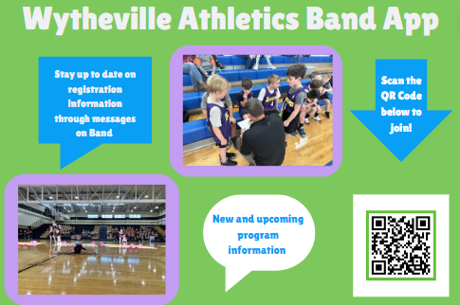
- New and upcoming programs
- Use QR code below to join

